MG – Fund Management Business (Meeting with Craig Young - 27th June)

History

- Original fund created in 1994, capitalisation $40m ($10m MG, $30m Third party)
- Liquidated in 1995
- Legal entity structure maintained
- Recreation of Metal fund business included in the 1999 float prospectus
- Reactivated in Nov 1999.

Current Business Structure

The current set-up does not represent the business plan. The existence of MG Metal Fund is purely a demonstration that the business has started. The number of funds falling under the MG Funds umbrella will be determined by limits applied to investment & expansion.

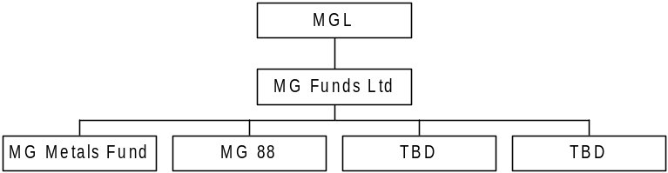 etc

MG Funds Ltd

- Guernsey registered entity
- Created from the old Metal Funds company as this minimised complexity of setting up the new group.

MG Metal Fund Ltd

- Guernsey registered entity
- Holds long positions only (MG Metal Index)
- Basket of metals
- Leverage up to 150%
- All MG money
- Value approx. $1m
- See www.mgfunds.com

MG 88 Ltd

- Guernsey registered entity
- $3m MG money
- $3m managers money (John Tilney, 25 years industry experience, from Glencore)
- Will trade anything as a hedge fund – expertise is Copper (and to a lesser extent Nickel)
- Leverage up to 300%
- This will be a Discretionary Global Hedge Fund (see business plan below).
- Currently being established. Ready to run from end of June 2000.

TBD

Structure of the business allows set-up of new funds under the MG Fund umbrella using short reports (5-8) pages instead of full listing documents. It is not unusual for there to be several hundred funds under this form of financial services group structure.

Business Plan

Create a business under the umbrella of MG funds made up of four components:

- Systematic Futures CTA (Commodities Trading Advisor) –Makes use of IT solutions to generate significant element of P&L from significant trend following activity. Team to include research and systems to support the business i.e. not just the key person (looking at NuWave team).
- Fixed Income / Currency trading – Leveraged day/week/long term/discretionary trading activity with potential (via existing contacts) to provide additional access to the capital markets for the group.
- Traditional Hedge funds – Allows exposure to pension funds that have remit to invest a portion of their funds in alternative markets. Hedge element refers to the fact that the fund will leverage exposure by trading using margin and therefore will not use a large element of the cash provided to the firm in the form of capital (85-90% not used).
- Discretionary Global Macro Hedge Fund – Long term trading of economic trends. Trade global futures on non-ferrous metals, precious metals, soft commodities and stock market indices. Ultimate investment activity at the discretion of the fund manager.

As the business develops create specific funds tailored to the market demand – several hundred funds is not unknown in the industry.

Financing:

- Structure is as a for venture capital operations
- MG/Enron provides seed capital
- Fund manager provides capital and has equity stake in the firm
- 3rd party investors provide additional capital
- Leverage aspect of trading activities allows the fund to lend money back to MG/Enron at LIBOR – provides funding source for the group but maintains callable capital for trading activity
- Guernsey is not regulated by the SFA
- A typical deal notional may be $300m of exposure achieved by geared exposure off $50m of credit lines and $10m of equity.

Exit:

- Secondary Market in Funds - Subject to market demand for entry into the funds, have a secondary market (as for investment companies).
- IPO for a complete financial services business

Key Markets:

- Structured products (e.g. Guaranteed capital bonds utilising ZCBs) to the retail and commercial market
- Pension funds
- Collaborations with major commodity players. In mature markets with stable prices (i.e. low volatility) and homogenous costs across the industry there is a the potential for major market players to combine funds in a fund (in contrast to a JV, which is not a separate legal entity, and hence subject to charges of collusion) and make use of their market knowledge in realising additional profits from the market.
- Internet trading
- High net worth individuals
- Insurance companies
- Financial institutions

Competition:

- ED&F Man
- Goldman Sachs (Commodity Corp)
- Chase Asset Management
- AIG
- Cap Z / Merril Lynch
- Asset Allianz

Tactical Management:

- Acquire teams from third parties
- Management team remuneration to include equity stake in the fund

Support Services:

- Separate company (MG/Enron) to provide a service agreement
- Accounting currently provided by a third party in Guernsey
- Valuations for Metal fund provided by Al Pennisi in New York

Income drivers:

- Management fees (typically 2% of funds under management pa)
- Performance fees (typically 20% of return pa)
- Brokerage
- Participation in equity
- Interest Income

Quality of earnings dependent on:

- Maturity of funds
- Size of funds
- Redemption rate

Earnings growth dependent upon:

- Fund performance
- New product development
- Distribution network

Key issues

- Approach to control
- Provision of support services
- Access to third party funds
- Acquisition and remuneration of the fund management teams

